INTERNSHIP COURSE
WEEK 3 TASK REPORT
FEATURE ENGINEERING & PREPROCESSING TECHNIQUES
Apparel & Textiles Industry with a Focus on Machine Learning
Submitted By
GUGULOTH NITHIN
Domain: Apparel & Textiles – Data Analytics & Machine Learning
Task: Week 3 –Feature Engineering & Preprocessing Techniques
Internship Course
August 2026

1. Executive Summary
This Week 3 report presents a structured feature engineering and data preprocessing strategy for the Apparel & Textiles domain, building on the earlier work on social media strategy, market analysis, audience behavior, content planning, and editorial calendars. The purpose is to convert raw public datasets into reliable, consistent, and machine-learning-ready data that can support business questions such as predicting engagement, identifying high-performing content, understanding customer segments, estimating product demand, and evaluating factors associated with apparel sales.
The proposed workflow begins with data profiling and quality assessment, followed by missing-value treatment, duplicate removal, inconsistency correction, outlier analysis, feature selection, transformation of numerical and categorical variables, text-related feature extraction, and dimensionality reduction where appropriate. Special attention is given to apparel-specific variables such as product category, fabric type, season, price, discount, color, size, inventory, customer rating, engagement metrics, content type, platform, posting time, and campaign characteristics.
The report also explains why every preprocessing step is necessary, what risks can occur if it is skipped, and how the final features can improve model performance, interpretability, and reproducibility. A realistic implementation plan, validation strategy, feature dictionary, quality checklist, and expected outcomes are included to demonstrate a systematic internship-level approach.

2. Task Objectives
- Design a complete preprocessing pipeline for public apparel, textile, e-commerce, and social-media-related datasets.
- Identify data-quality problems that can reduce the reliability of machine-learning models.
- Propose appropriate methods for missing values, outliers, duplicates, inconsistent labels, and invalid records.
- Identify and prioritize features that are likely to influence apparel sales, customer behavior, and social-media engagement.
- Recommend numerical scaling, categorical encoding, text transformation, and optional dimensionality-reduction methods.
- Prevent data leakage and ensure preprocessing is fitted only on training data during model development.
- Create a feature dictionary and quality-control checklist that make the workflow understandable and reproducible.
- Connect preprocessing decisions with business objectives in the apparel and textiles industry.

3. Project Context and Business Problem
The internship work focuses on the Apparel & Textiles industry with an emphasis on market analysis and digital/social-media strategy. Public datasets can provide information about products, prices, categories, customer reviews, transactions, campaign performance, social-media posts, and engagement. However, such datasets are rarely ready for direct machine-learning use. Values may be missing, duplicated, recorded in different units, represented by multiple spellings, or affected by extreme observations.
A suitable Week 3 objective is therefore to establish a reusable data-preparation pipeline. For example, a future model could predict social-media engagement or classify content into high- and low-performing posts. Another model could predict apparel demand from product and seasonal attributes. In both cases, the quality of the engineered features strongly influences the quality of the final model.
The central principle used in this report is: raw data → profiling → cleaning → feature engineering → transformation → validation → model-ready dataset. Each stage should be documented so that another analyst can reproduce the same result.

Figure 1. Proposed System Architecture
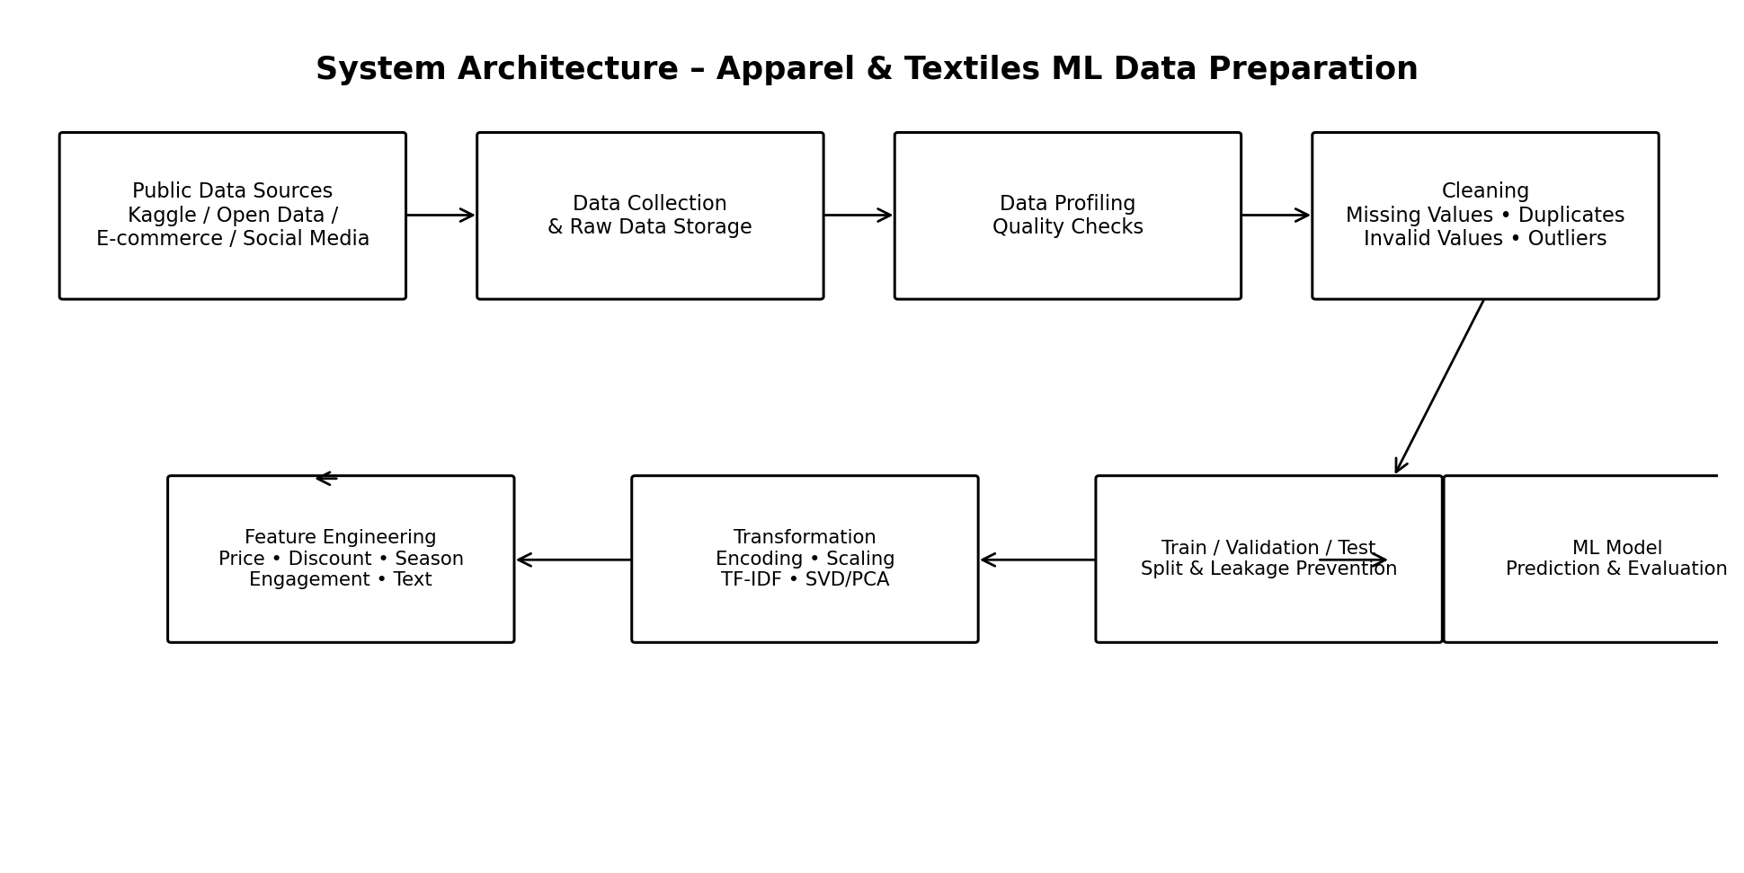

4. Proposed Public Dataset Sources and Data Structure
The strategy is designed to work with publicly available datasets from sources such as Kaggle, UCI-style repositories, government/open-data portals, public e-commerce datasets, and openly accessible social-media datasets. The report does not assume that one specific dataset contains every variable. Instead, it defines a hypothetical integrated structure that can be adapted to the selected public dataset.

Dataset Type: Possible ML Use
Apparel product dataset
product\_id, category, fabric, color, size, price, discount, rating
Demand/sales prediction; product segmentation
E-commerce transaction dataset
date, product\_id, quantity, revenue, customer\_id, channel
Demand forecasting; customer analysis
Social-media content dataset
platform, post\_type, caption, hashtags, posting\_time, likes, comments, shares
Engagement prediction; content classification
Customer review dataset
review\_text, rating, product\_category, verified\_purchase
Sentiment analysis; rating prediction
Inventory dataset
SKU, stock\_level, reorder\_point, sales\_velocity, season
Stock-risk prediction; inventory planning
Market/seasonal dataset
month, season, festival\_period, region, temperature
Seasonal demand modeling

5. End-to-End Feature Engineering Workflow
- Define the business question and target variable before touching the data.
- Collect the selected public datasets and document source, date, license, columns, and known limitations.
- Create a raw-data copy and never overwrite the original dataset.
- Profile data types, missingness, unique values, ranges, duplicates, and inconsistencies.
- Clean records and standardize units, labels, dates, and formats.
- Treat missing values using methods appropriate to the meaning and distribution of each feature.
- Detect and investigate outliers rather than automatically deleting them.
- Create meaningful derived features from dates, prices, discounts, text, and engagement metrics.
- Select relevant features using domain knowledge and statistical/model-based techniques.
- Encode categorical variables and scale numerical variables where the selected algorithm requires it.
- Optionally reduce dimensionality for high-dimensional numerical/text representations.
- Split data into training/validation/test sets and fit preprocessing only on training data.
- Validate the processed dataset using quality checks and compare model performance before and after preprocessing.

6. Data Profiling and Initial Assessment
Data profiling is the first technical step because preprocessing decisions should be evidence-based. The analyst should inspect the shape of the dataset, data types, missing-value percentage, number of unique values, descriptive statistics, duplicate rows, and suspicious categories.

Method/Question: Expected Action
Dimensions
How many rows and columns exist?
Record baseline dataset size
Data types
Are numeric, categorical, date, and text columns correctly typed?
Convert incorrect types
Missingness
What percentage is missing in each feature?
Impute, flag, or drop based on importance
Duplicates
Are rows or IDs repeated?
Remove true duplicates; investigate repeated transactions
Ranges
Are price, rating, quantity, and engagement values realistic?
Correct invalid values or investigate
Categories
Are labels standardized?
Map variants to canonical labels
Dates
Are dates valid and consistently formatted?
Parse and standardize
Target leakage
Does a feature contain information unavailable at prediction time?
Remove or redesign feature

7. Data Cleaning Strategy

7.1 Duplicate Records
Duplicate records can artificially increase the importance of repeated observations and can cause overly optimistic evaluation results. Exact duplicate rows should be removed. For business datasets, duplicate-looking rows should not be deleted automatically because two identical purchases or posts may be legitimate events. A stable identifier such as transaction\_id, post\_id, or product\_id plus timestamp should be used where possible.

7.2 Inconsistent Categories
Apparel data often contains variations such as 'T-Shirt', 'Tshirt', 'T shirt', or inconsistent capitalization. A canonical mapping table should be created. Similar treatment is required for fabric names, colors, gender categories, product types, platforms, and campaign labels.

7.3 Units and Formats
Numerical variables should use common units. Prices should use a consistent currency, weights should use a consistent unit, and percentages should be stored consistently. Dates should be converted into a standard datetime format. This prevents a model from interpreting the same real-world quantity as different values.

7.4 Invalid Values
Business rules should be used to identify impossible values. Examples include negative product quantity where returns are not represented, ratings outside the valid scale, discount percentages below 0 or above 100, invalid dates, and negative inventory when negative stock is not meaningful. Invalid values should be corrected from reliable source information where possible or marked as missing rather than silently changed.

8. Handling Missing Values
Missing values are common in public datasets and may occur because a field was not collected, a customer skipped a question, a product attribute was unavailable, or a source system used different schemas. The correct method depends on the variable's meaning and the percentage and pattern of missingness.

Recommended Treatment: Reason
Numerical – low missingness
Median imputation; optionally add missing indicator
Robust to skewed apparel prices and quantities
Numerical – time series
Forward/backward fill only when logically valid
Preserves temporal context
Categorical
Mode or explicit 'Unknown'
Avoids losing records and preserves missingness information
Text
Empty/Unknown category or missing flag
Separates absent text from meaningful text
Critical identifier
Investigate; do not blindly impute
IDs should normally be unique and real
High-missingness feature
Consider dropping after business review
May add noise if little information remains
Target variable
Usually remove from supervised training rows
Target cannot be safely fabricated
Missingness itself can sometimes carry information. For example, missing fabric composition might occur more often for certain product sources. A binary feature such as fabric\_missing\_flag can therefore be created when it is meaningful. Imputation values must be learned from the training set only to avoid data leakage.

9. Outlier Detection and Treatment
Outliers should be investigated rather than automatically removed. In apparel datasets, a very high price may represent a premium product, and a very high engagement count may correspond to a successful campaign. Removing such valid observations could reduce the model's ability to learn important business patterns.
- IQR method: flag values below Q1 − 1.5×IQR or above Q3 + 1.5×IQR.
- Z-score: useful for approximately normal variables, but less suitable for heavily skewed prices or engagement.
- Percentile capping/winsorization: cap extreme values when the model is sensitive to large magnitudes.
- Log transformation: useful for right-skewed variables such as revenue, quantity, views, or follower counts.
- Business-rule validation: check whether an extreme value is valid before changing it.
- Separate anomaly detection: suspicious records can be flagged for review rather than deleted.

10. Feature Engineering Strategy
Feature engineering converts raw columns into representations that better capture the underlying business behavior. The following features are proposed for apparel and social-media analysis.
Figure 2. Feature Engineering Map
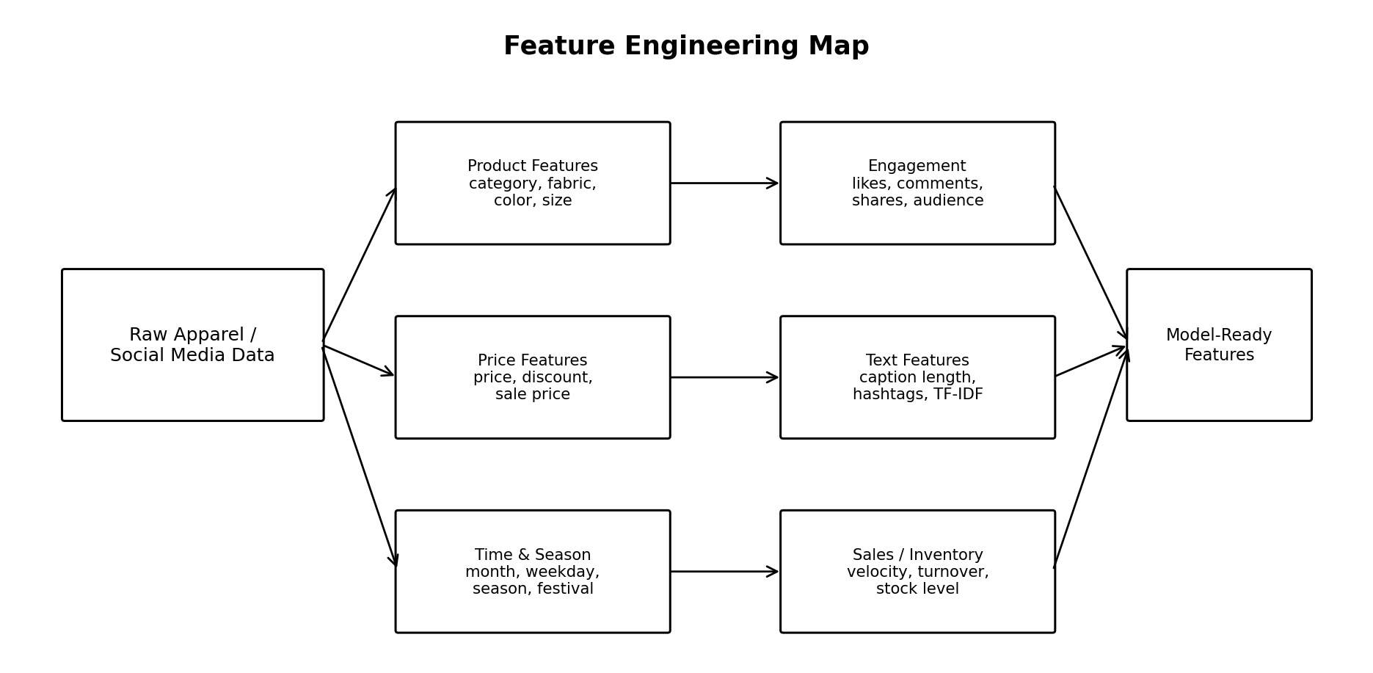

Raw Information: Engineered Feature
Price and discount
discount\_amount, discount\_rate, sale\_price
Capture promotion intensity and effective price
Date/time
month, week, day\_of\_week, hour, weekend\_flag
Capture seasonality and posting-time effects
Date + festival
festival\_period, season
Represent demand/engagement cycles
Product category
category\_group
Reduce overly fragmented labels
Inventory + sales
stock\_turnover, sales\_velocity
Represent product movement
Reviews
average\_rating, review\_count
Measure perceived product quality and social proof
Social engagement
engagement\_rate, total\_interactions
Normalize performance by audience size
Caption/hashtags
caption\_length, hashtag\_count, keyword flags
Convert text metadata into useful numeric signals
Product attributes
fabric\_group, color\_group, size\_count
Capture product characteristics
Price + category
category\_price\_index
Compare price relative to category
Historical performance
rolling\_mean\_engagement or prior\_sales
Capture previous behavior without future leakage

11. Feature Selection
Feature selection reduces irrelevant, redundant, and noisy variables. It can improve generalization, reduce training time, simplify the final model, and make business interpretation easier. Selection must be performed without using information from the test set.

11.1 Domain-Based Selection
Start with variables that have a logical relationship with the target. For engagement prediction, platform, content type, posting time, caption characteristics, follower/audience size, campaign type, and previous engagement may be useful. For apparel demand, price, discount, category, season, fabric, inventory, historical sales, rating, and region may be relevant.

11.2 Statistical Selection
- Correlation analysis for numerical variables to identify strongly related predictors and redundancy.
- Mutual information to identify nonlinear relationships between features and target.
- Chi-square or similar tests for categorical variables where appropriate.
- Variance threshold to remove near-constant features.

11.3 Model-Based Selection
- L1 regularization can shrink weak coefficients toward zero.
- Tree-based feature importance can identify variables that contribute to prediction.
- Permutation importance can estimate the performance impact of a feature after a model is trained.
- Recursive feature elimination can iteratively remove less useful variables.

12. Feature Transformation Techniques

12.1 Numerical Scaling
Scaling is especially important for algorithms based on distances or gradient optimization, including K-Nearest Neighbors, K-Means, Support Vector Machines, and many neural-network workflows. Tree-based models generally do not require scaling, but a consistent pipeline can still be useful.

Technique: Use Case
Standardization
Features with different units and approximately symmetric distributions
Transforms using mean and standard deviation
Min-Max scaling
Bounded input range is useful
Maps values to a fixed interval such as 0–1
Robust scaling
Data contains substantial outliers
Uses median and IQR
Log1p transformation
Strong right skew
Useful for sales, revenue, views, likes, and counts

12.2 Categorical Encoding
- One-hot encoding: suitable for low-cardinality variables such as platform or season.
- Ordinal encoding: use only when categories have a meaningful order.
- Frequency encoding: useful for high-cardinality categories when category frequency is informative.
- Target encoding: can be powerful but must be performed inside cross-validation/training folds to prevent leakage.
- Rare-category grouping: combine very infrequent labels into an 'Other' group when appropriate.

12.3 Text Transformation
For review text, captions, product descriptions, or hashtags, the text can be converted into machine-readable features. A basic approach is TF-IDF, which captures the importance of words relative to the document collection. Additional features such as text length, word count, hashtag count, punctuation count, and sentiment score can complement TF-IDF. If a large text representation is created, dimensionality reduction may be considered.

12.4 Dimensionality Reduction
High-dimensional feature spaces can occur after one-hot encoding or TF-IDF. Principal Component Analysis (PCA) can reduce correlated numerical dimensions while retaining much of the variance. For sparse text matrices, Truncated SVD is generally more appropriate than ordinary PCA. Dimensionality reduction should be evaluated for both predictive performance and interpretability because compressed components are harder to explain in business terms.

13. Data Leakage Prevention
Data leakage is one of the most important risks in preprocessing. Leakage occurs when information that would not be available at prediction time is used to construct a feature or preprocessing rule. For example, using future sales to predict today's sales, calculating target encoding from the complete dataset, or scaling the test set together with training data can produce unrealistic performance.
Figure 3. Leakage-Safe Preprocessing Workflow
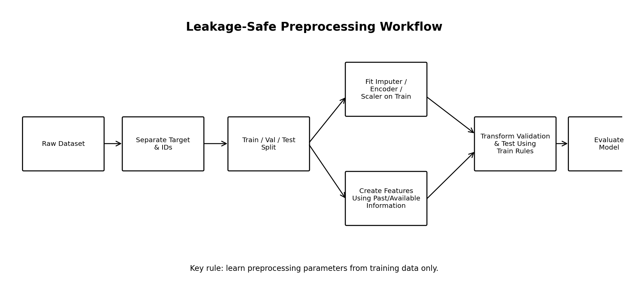
- Split data before fitting imputers, scalers, encoders, or feature selectors.
- For time-based problems, use chronological splits rather than random splits when future prediction is the goal.
- Create historical/rolling features using only information available before the prediction timestamp.
- Fit target encoding and other target-dependent transformations inside training folds.
- Keep the test set untouched until final evaluation.

14. Proposed Machine Learning Preprocessing Pipeline
A reproducible pipeline should combine preprocessing and modeling so that the same transformations are applied consistently during training and inference.
- Load raw public dataset.
- Separate target variable and identifiers.
- Create train/validation/test split using the correct random or chronological strategy.
- Apply numerical imputation using training data.
- Apply categorical imputation and category standardization.
- Generate engineered features that are available at prediction time.
- Encode categorical variables.
- Scale numerical variables when required by the model.
- Transform skewed variables and process text features.
- Optionally reduce dimensions for high-dimensional representations.
- Train the machine-learning model.
- Evaluate on validation/test data using appropriate metrics.
- Save the preprocessing and model pipeline for reproducibility.

15. Before vs. After Preprocessing

Aspect: Raw Data

After Preprocessing:
Missing values
Blank/NaN values
Imputed or explicitly flagged
Categories
Mixed spellings/case
Standardized categories
Dates
Multiple formats
Consistent datetime features
Price
Mixed scale/skew
Consistent currency and transformed/scaled where needed
Text
Raw captions/reviews
TF-IDF/metadata features
Outliers
Uninvestigated extremes
Validated, flagged, transformed, or capped when justified
Features
Raw columns only
Domain-informed derived features
Model input
Inconsistent types
Structured numeric/encoded matrix
Reproducibility
Manual cleaning
Documented pipeline

16. Apparel & Textiles-Specific Insights
- Seasonality is critical: fashion demand and content performance can change across summer, winter, festive periods, and regional events.
- Discounts should be separated into original price, discount rate, and final sale price so that promotion effects are interpretable.
- Product category and fabric can interact; for example, the same price level may have different meanings across product categories.
- Color and size are categorical attributes and should not be treated as ordinary numerical values.
- Engagement counts should often be normalized by audience size to avoid simply rewarding larger accounts.
- Historical features should be carefully time-aware because future information can leak into training.
- Text features can capture customer sentiment and content themes that are not represented in structured product columns.
- Rare product categories may need grouping, but rare categories should not be merged without considering business importance.

17. Data Quality and Preprocessing Checklist
- Original raw dataset preserved.
- Source, collection date, and license documented.
- Column names standardized.
- Data types verified.
- Duplicate records investigated.
- Missingness profile generated.
- Invalid ranges identified.
- Categorical labels standardized.
- Units and currencies standardized.
- Outliers investigated using statistical and business rules.
- Target variable defined before feature selection.
- Potential leakage variables reviewed.
- Feature dictionary created.
- Train/validation/test split performed before fitting transformations.
- Imputation, encoding, and scaling fitted only on training data.
- Engineered features checked for logical validity.
- High-dimensional features reviewed for dimensionality reduction.
- Final processed dataset contains no unexpected data types or missing values.
- Model performance compared with a baseline.
- All preprocessing decisions documented for reproducibility.

18. Conclusion
Feature engineering and preprocessing provide the bridge between raw public data and reliable machine-learning analysis. For the Apparel & Textiles domain, preprocessing must account for fashion categories, pricing and discount behavior, seasonal demand, customer reviews, social-media engagement, and high-cardinality product attributes. A simple one-size-fits-all cleaning strategy is not sufficient because an extreme value can be either an error or an important business event.
The strategy developed in this report therefore combines statistical methods with domain knowledge. Missing values are treated according to feature meaning, outliers are investigated before modification, categorical variables are standardized and encoded appropriately, numerical variables are transformed when necessary, and high-dimensional text or categorical representations can be reduced when justified. Most importantly, all learned preprocessing operations must be fitted only on training data to prevent leakage.
The resulting workflow is designed to improve data quality, model stability, computational efficiency, and interpretability. It also creates a clear foundation for future machine-learning work such as engagement prediction, apparel demand forecasting, customer segmentation, sentiment analysis, and product-performance analysis.

19. Suggested References and Tools
- Python – pandas for data cleaning, transformation, and tabular analysis.
- NumPy for numerical operations.
- scikit-learn for preprocessing, feature selection, dimensionality reduction, and machine-learning pipelines.
- Matplotlib/Seaborn for exploratory data visualization and outlier/distribution analysis.
- Public dataset documentation and metadata should always be reviewed before using a dataset.
- Kaggle/public repositories/open-data portals may be considered as dataset discovery sources subject to their individual licensing and usage terms.

